**Digital Modulation Schemes**

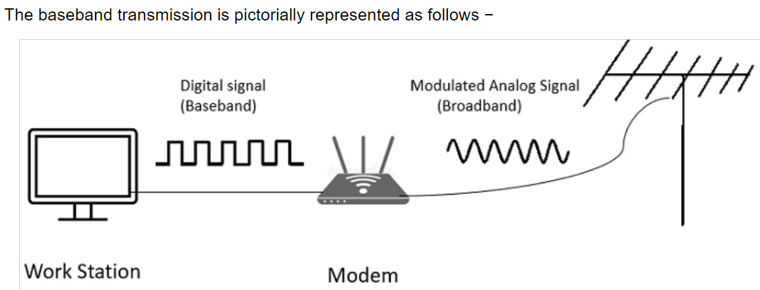

**Baseband transmission:**

